# **Computer Hardware Identification**

**Date:**

**Group Name:**

**Group Members (2 Max):**

In this activity, in groups of 2, you will be taking a computer apart. Using a working computer and a phone, take pictures of the components and enter a description of the component and what it does. If the computer that is being dissected does not have the component, then getting an image from the internet is acceptable. Identify and describe the following computer components:

1. Case
   * Image: 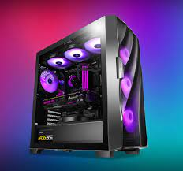
   * Description: metal weetbix sized box
   * Function: protects inside
2. Motherboard
   * Image: A picture containing text, electronics, circuit

     Description automatically generated
   * Description: the main printed circuit board in a computer
   * Function: the backbone that ties the computer's components together at one spot and allows them to talk to each other
3. CPU
   * Image: A picture containing circuit

     Description automatically generated
   * Description: The component of a computer system that controls the interpretation and execution of instructions
   * Function: logic, control, arithmetic, input and output operations
4. GPU
   * Image: A picture containing fan, indoor, device, projector

     Description automatically generated
   * Description: a specialized processor originally designed to accelerate graphics rendering
   * Function:  accelerate graphics rendering
5. RAM
   * Image: A close-up of a circuit board

     Description automatically generated with medium confidence
   * Description: random-access memory
   * Function: a temporary memory bank where your computer stores data it needs to retrieve quickly
6. Storage Device
   * SSD vs HDD
7. Cooling
   * CPU
     1. Image: 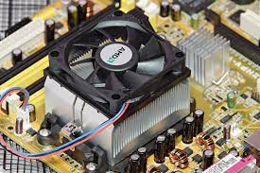
     2. Description:  heat sinks which are specifically designed to remove waste heat generated by a central processing unit
     3. Function: absorb heat from the CPU and redistribute it away from the hardware
   * Chassis
     1. Image:
     2. Description:
     3. Function:
8. PSU (Power Supply Unit)
   * Image: A close up of a speaker

     Description automatically generated with low confidence
   * Description: a hardware device that converts AC electricity into DC electricity and then distributes it to the rest of the computer.
   * Function: converts the alternating high voltage current into direct current , and they also regulate the DC output voltage to the fine tolerances required for modern computing components.
9. Monitor
   * Image: A picture containing text, display, light

     Description automatically generated
   * Description: an electronic output device that is also known as a video display terminal or a video display unit
   * Function:  displays information in pictorial or textual form.
10. Mouse
    * Image: Icon

      Description automatically generated
    * Description: a small device that a computer user pushes across a desk surface in order to point to a place on a display screen and to select one or more actions to take from that position.
    * Function: controls the motion of a pointer in two dimensions in a graphical user interface
11. Keyboard
    * Image: A picture containing computer, indoor

      Description automatically generated
    * Description: for putting information including letters, words and numbers
    * Function: It’s a input device